TAHSEEN ALAM

TASK 5

WIRESHARK

Steps :

1.Start the wireshark

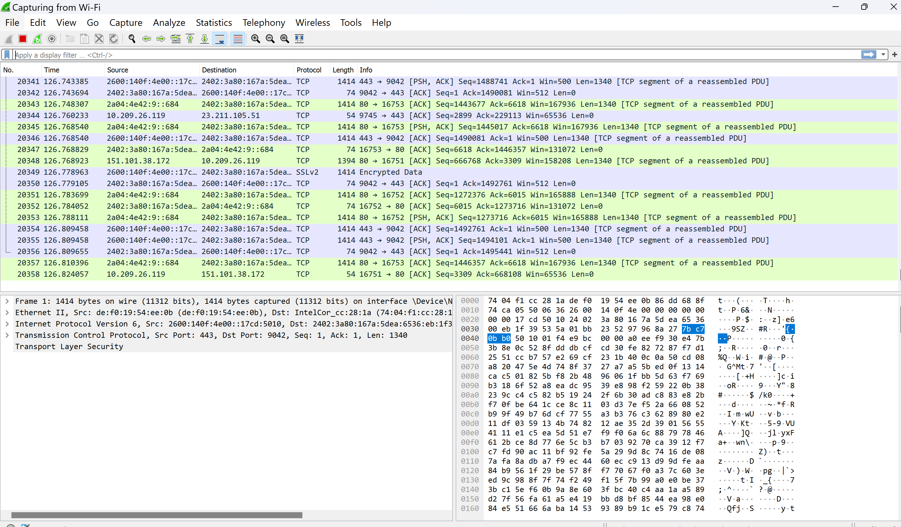

2. It starts capturing the packets

3. Start a browser

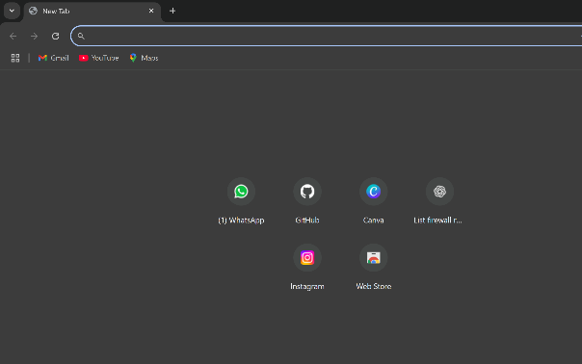  
4. Filter the traffic by Protocols (e.g. HTTP, DNS, TCP)

1. http

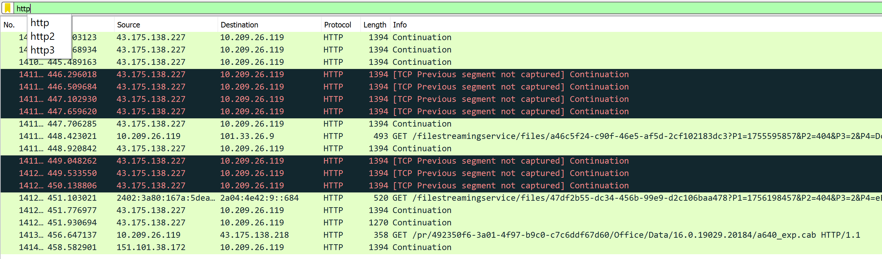

1. dns

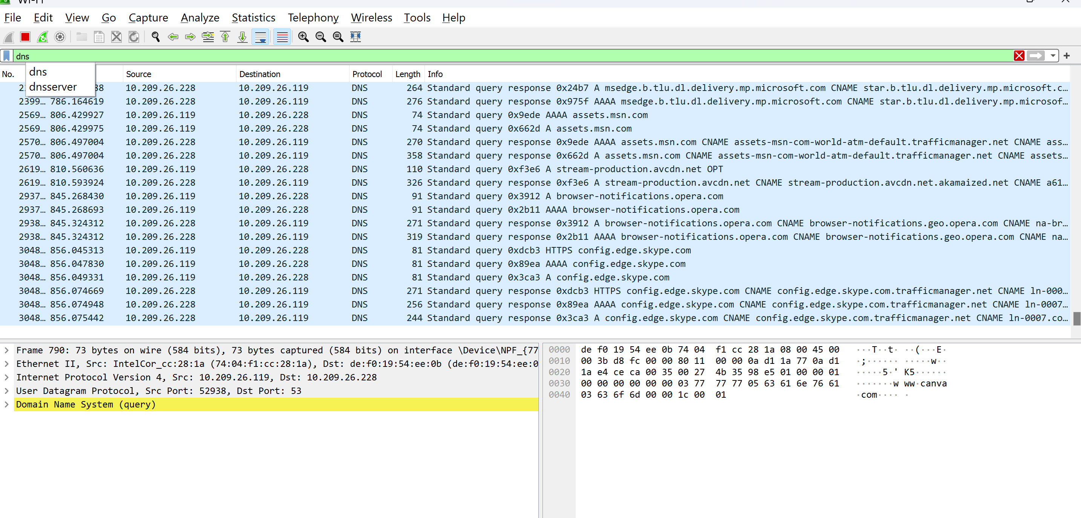

c)tcp

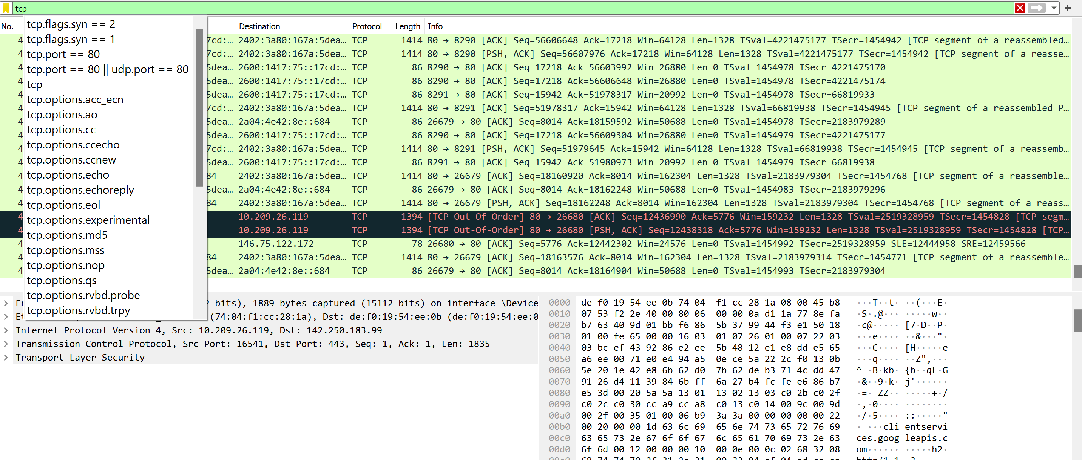

1. ip. addr == 10.209.26.119

